Modeling data distributions

Percentiles

Calculating percentile
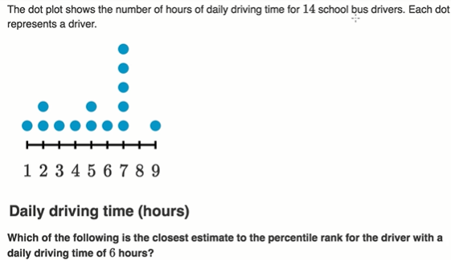
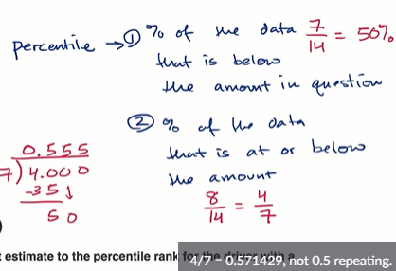

Analyzing a cumulative relative frequency graph
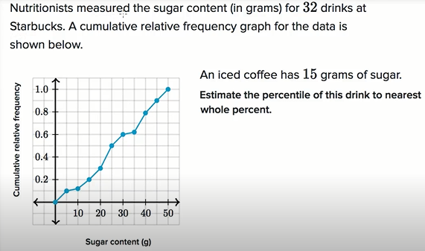
→20
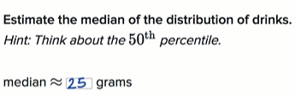

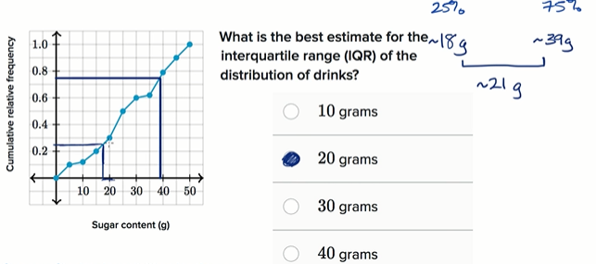

Z-scores
Z-score is literally measuring how many Standard deviations away from the mean.
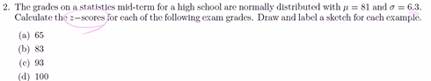

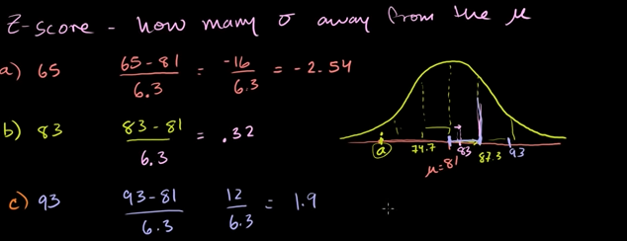
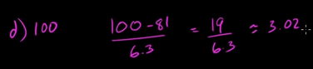

We see datapoint 100 is 3*S.D away from the mean.
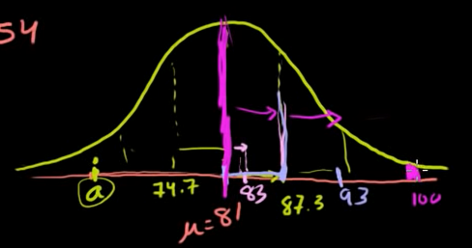

A bit confused at 7.24
Sal says, 100 is very low probability, that what the chart tells, the hieght, There is very low probability of getting something higher than that. We learned in probability density function, if its continious and not discrete, the probability of exactly that is zero

Comparing with z-scores
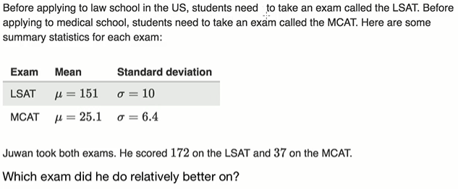
>>>
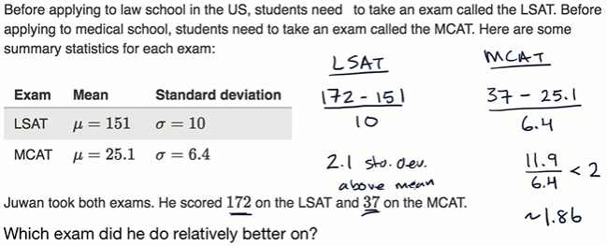

Effects of linear transformation

How parameters change as data is shifted and scaled
You see students age and calculate parameters and will see how these paramter changes as we add,sub,mul,div.
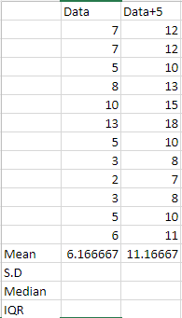
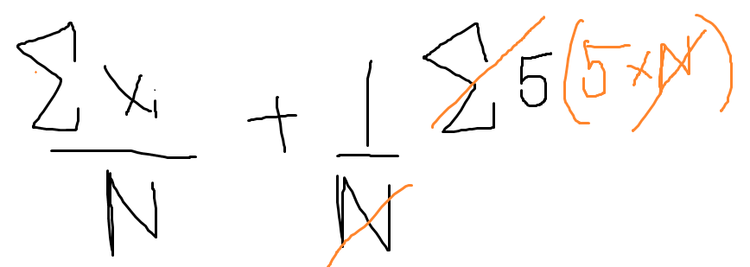

So if we add 5 to every data point, the mean will be move forward by 5.

Multiply:
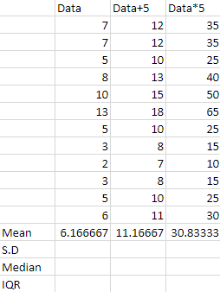
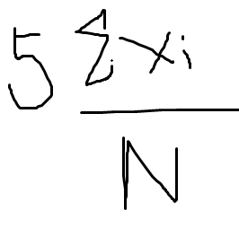

We see our mean is 5 times bigger
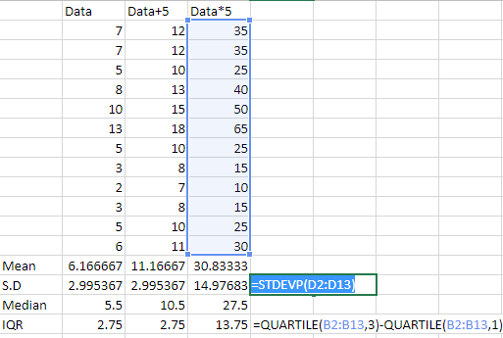

Modeling data distributions

Density curves
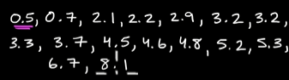

Frequency histogram
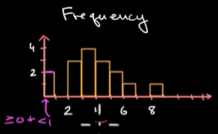

We have created category, so 2 dp fall into (0<=x<1) So the bar is upto 2.
You wanna find what percentage of ur data fall into each of those categories
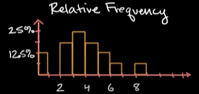
2/16=12.5%
4/16=25%

Frequency and relative frequency are very useful. But if we have many many dp. We might wanna have more granular categories.
So instead of making (0<=x<=1) make it (0<=x<=5) I.e instead of one glass of water everyday make it 1.2 glass of water everyday.
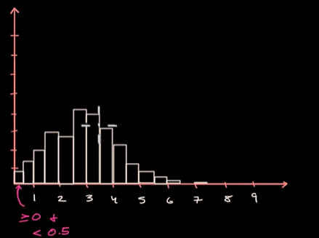

But maybe that is still not good enough for u
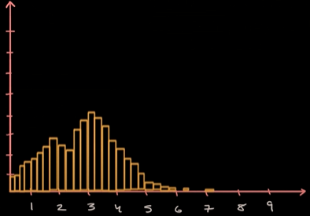

What if its still not good enough, and u wanna it to be more granular.
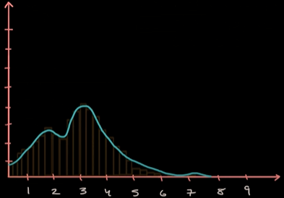

A time will come, with very very minute categories, u will get a curve
This is called as Density curves
Density curve: is a visulatization of distribution where the datapoints can take any value in the continium, they r not just thrown in the buckets.
We choose 9 cuz nobody drinks more than 9. So you can have close to 9. But not 9.
From 0 to 9, the area under the curve over the interval is gonna be 100%.
A density curve will never take on negative values.

So how to use it.
Q. What percentage of data of fall into 2-4?
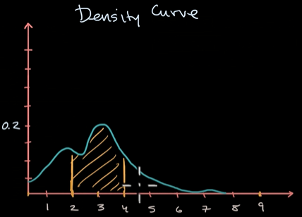

Ans: Area under the curve from interval 2-4.
By eyeballing it looks like its about 40% of the entire data under the curve.
Q. What percentage of data falls under under the curve from interval 3?
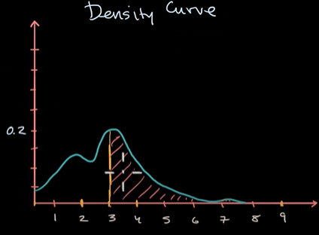

Even with estimation, density curves can be useful. Statistician may have tables that represent info about the density curves. They might have some computer program or some automated tool.
There also well known density curves: Bell curve. Where there is a lot of precise data and a lot of tools to help you figure out the areas.

Key misconception of density curves:
if I ask what percentage of my data is exactly 3 glass of water per day
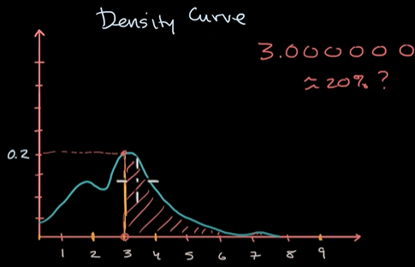

So, you wanna do that.
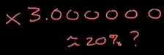
But its wrong.

Its the area under the curve for that interval.
In this case, if u wanna find exactly 3.0 glass of water per day.
There is no area under the curve. It has no width.
You can see in real world, nobody drinks exactly 3.00 glass of water/ day.
You can only ans the following type of question
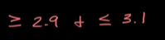

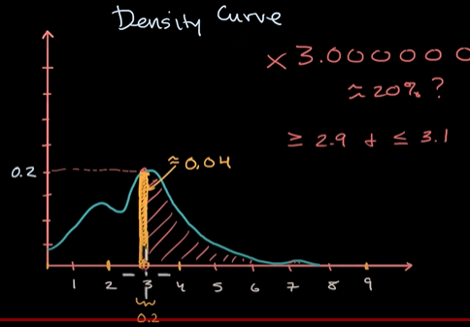
You can say 4% of the data fall under this interval.

Median,mean and skew from density curves
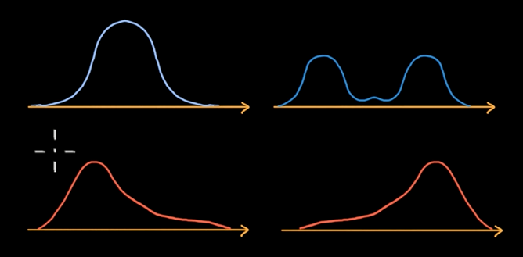
Density curve: which is a summary of distribution of data.
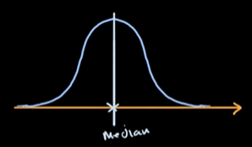
Here, median is a point half of the distribution is to the left and other half is at right. For a symmetric density curve, the median is along the line of symmetry.

Bi-modul distribution
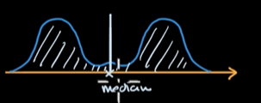
Area to the left is equal to the area on the right.

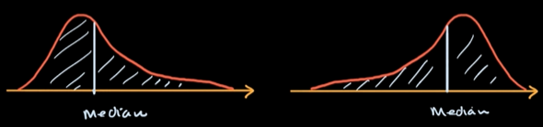

What about the mean?
You take each of the possible values and wieghted by their frequencies.
For symmetric distribution, the mean and the median is gonna be the same.
Makes sense.
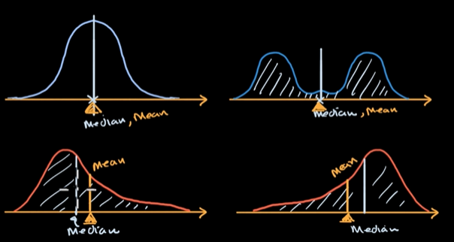
Distribution like this is referred to as skewed.
This distribution where u have mean to the right of the median is called Right skewed.

Density curve worked example
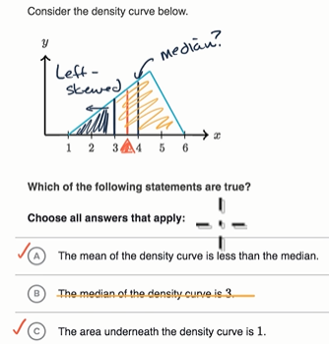
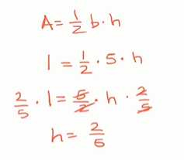

Worked example finding area under density curves
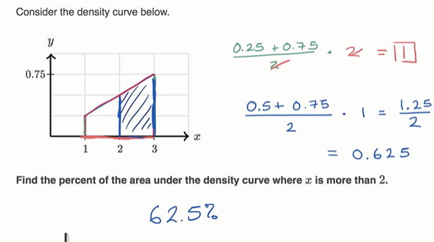

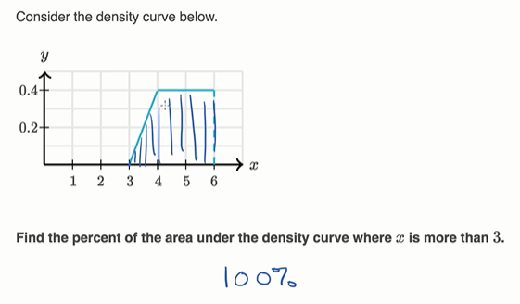

Qualitative sense of normal distributions
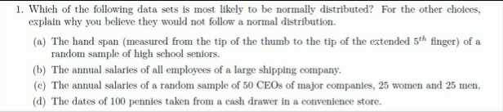
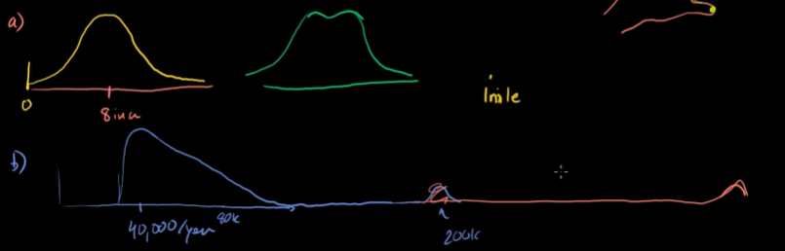
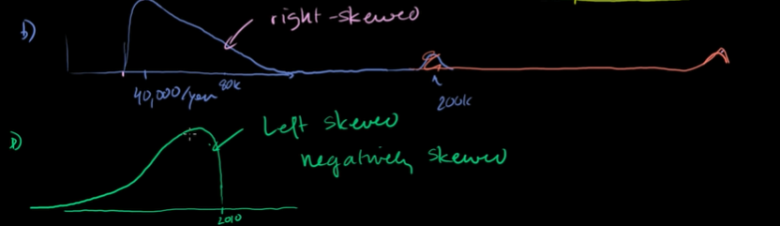

Normal distribution problems: Empirical rule
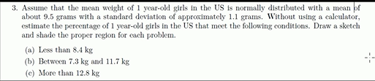

Without using a calculator estimate, means we have to use the empirical rule
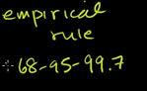

That tells when we have a normal distribution, it should be symmterical.
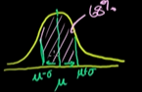
For one standard deviation away.

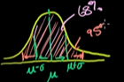

If we include 1 and 2 S.D from the mean both ways
its 95%. That includes the 68%.

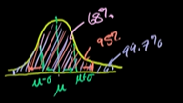
if we go 1,2 and 3 S.D both ways.
We have 99.7% chance.

68% tells there is68% chance of finding something within 1S.D

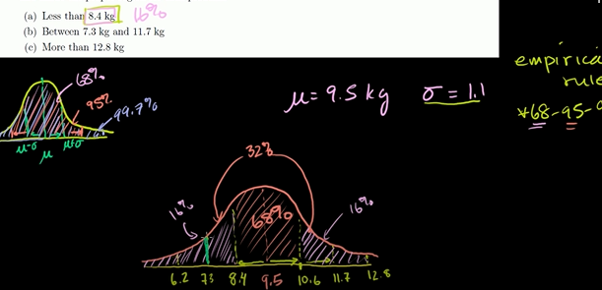
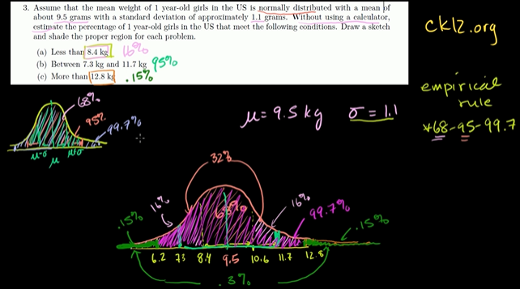

Standard normal distribution and the empirical rule
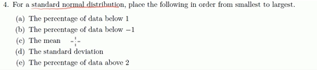

Normal distribution
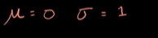
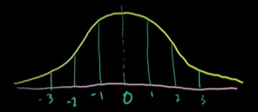

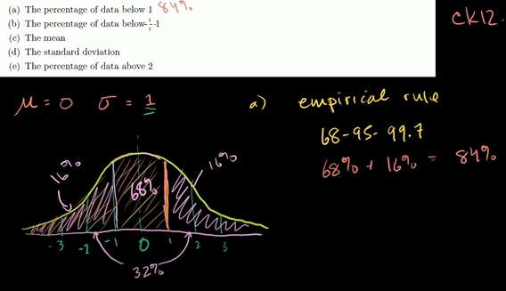

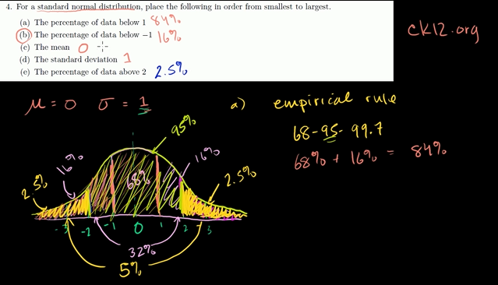
More Empirical rule and z-score practice
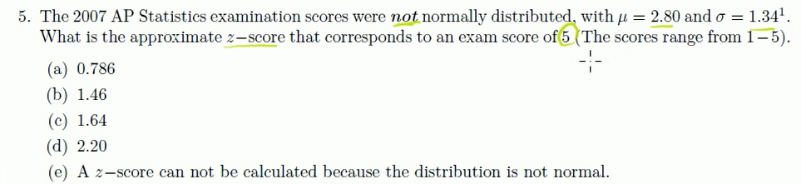
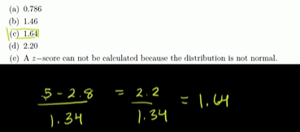

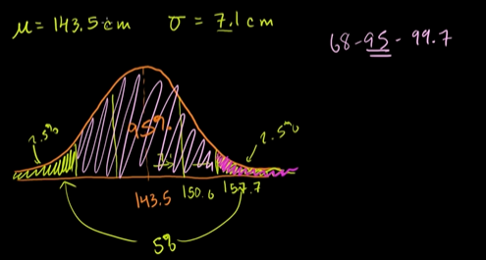

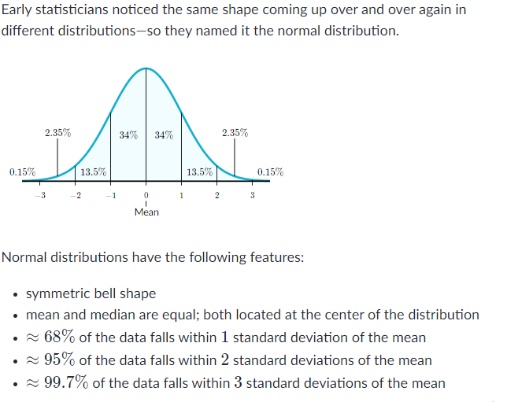

Normal distribution calculations

Standard normal table for proportion below
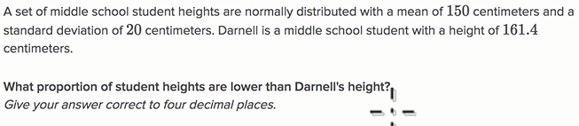
So we calc z-score and we can lookup into z-table, to see what proportion is less than that amount in a normal distribution.
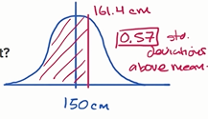

ans: 0.7157

Standard normal table for proportion above
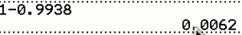
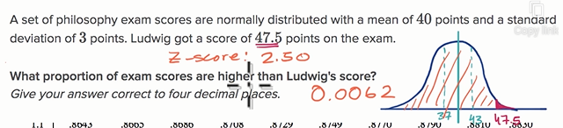

Standard normal table for proportion between values
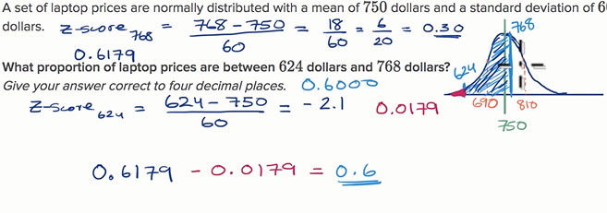

Finding z-score for a percentile
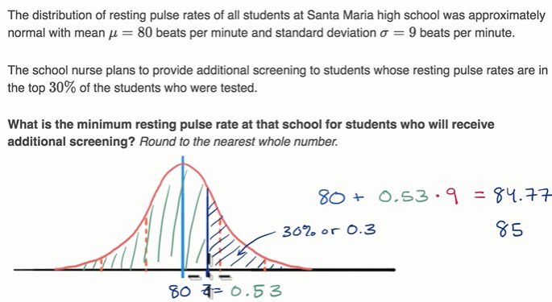
>>>
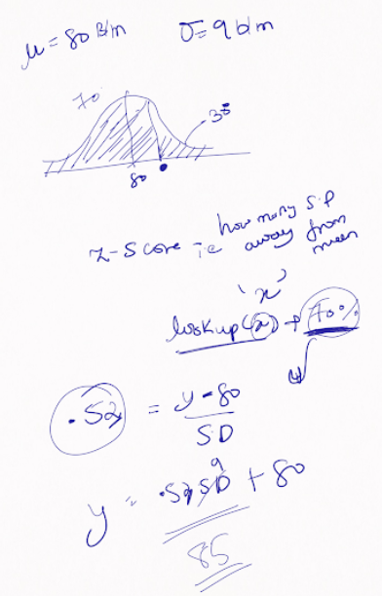

Threshold for low percentile
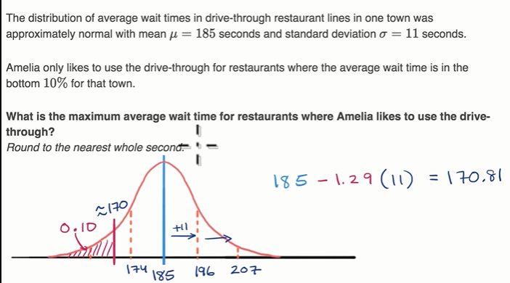

z-score tell what percentile is below the z-score.
Or what proportion are higher and lower from some point.

More on normal distribution PENDING

Deep definition of the normal distribution

